Stonyfield Farm’s Gary Hirshberg Joins Plant-based Yogurt Maker Hälsa
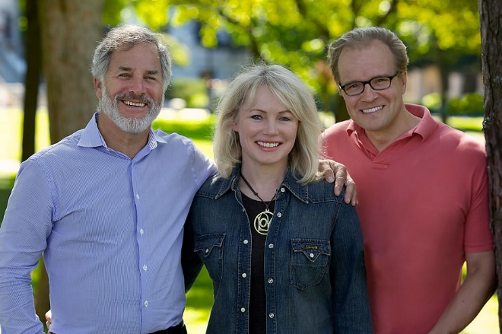
NEW YORK – December 3, 2019 – Gary Hirshberg, co-founder and former long-time CEO and Chairman of Stonyfield Organic, the world’s leading organic yogurt producer, has become an investor and board member of Hälsa Foods, the maker of the first and only 100% clean and organic oat milk yogurt. Hirshberg is a renowned pioneer and advocate of organic, sustainably grown food.
“Hälsa has done something other plant-based brands have not been able to do by creating a completely clean, additive-free process and label with minimal ingredients and no added sugar,” Hirshberg commented. “I was attracted to Hälsa yogurts because of their superb taste and texture, but also because I believe that the future of plant-based is absolutely organic.”
“We are thrilled to welcome Gary, a visionary change maker who truly cares about what people eat,” said Helena Lumme and Mika Manninen, President and CEO of Hälsa Foods.
In addition to Hirshberg, Andrew Abraham, the founder and CEO of Orgain, also joins Hälsa as a new investor. Danone Manifesto Ventures, the venture arm of Danone, which had invested in the earlier company seed round also participated alongside Hirshberg and Abraham.
Hälsa—Swedish for health—sets a new standard for the plant-based milk category by eliminating all food additives and chemicals from the manufacturing process and recipes: No enzymes are used to alter the grain and the all-organic products are free of gums, emulsifiers, phosphates and processed sugar that compromise gut health.
“The future of plant-based belongs to 100% clean label. Hälsa cracked the code by developing a new manufacturing process that keeps the nutritional benefits of whole grain oats intact,” Lumme added.
About Hälsa Foods
Hälsa Foods stands for healthier people and planet. The company was founded by Helena Lumme and Mika Manninen on their innovation of the new 100% clean plant-based platform. Hälsa Organic Oatgurts are sold at ShopRite, Fairway Market, Fresh Direct, all NYC airports, and at select New York metro area stores. Learn more at halsafoods.com, and follow along on Instagram, Facebook, Twitter and YouTube.

For more information, contact: Terri Slater / Halsa Publicist / terri@slaterpr.com / 561-350-6547 or 5W PR / Halsa@5wpr.com / 646-507-5706

