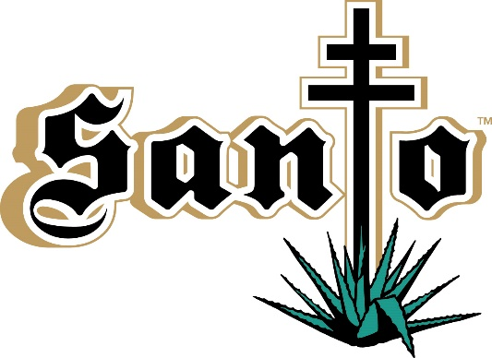
FOR IMMEDIATE RELEASE MEDIA CONTACT
April 5, 2019 Megan Roberts/Alexis Beresid
Wicked Creative: 702.868.4545
Megan.Roberts@wickedcreative.com
Alexis.Beresid@wickedcreative.com

Sammy Hagar and Guy Fieri Introduce
Santo Fino Blanco Tequila and Los Santo Partnership
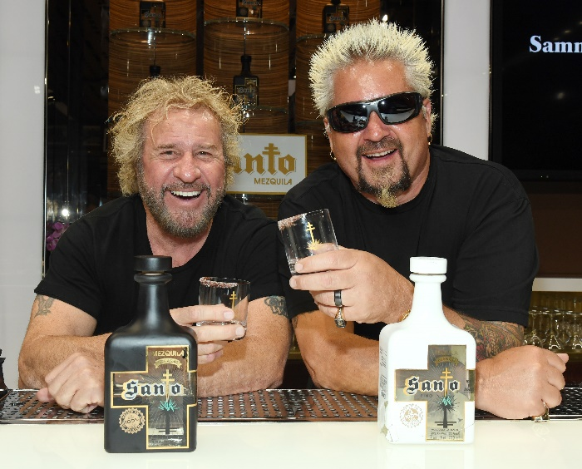

Tweet it!: @SammyHagar and @GuyFieri announce new partnership in Los Santo, known for the world’s first #mezquila, @SantoMezquila, and unveil new tequila, #SantoFinoBlanco. #Tequila #Mezquila #HigherSpirit

LAS VEGAS – Legendary rocker and spirits pioneer, Sammy Hagar, has joined forces with acclaimed Emmy Award winning chef and restaurateur, Guy Fieri, to create a new tequila: Santo Fino Blanco. Launching in May, Santo Fino Blanco is the second spirit in the Los Santo family, joining Santo Puro Mezquila, the world’s first and only blend of tequila and mezcal.

“Guy has always been a tequila lover and when he approached me about creating a tequila together it was perfect timing,” said Hagar. Sammy and Juan Eduardo Nuñez, the third-generation master distiller that originally worked with him to make his Cabo Wabo Tequila and later Santo Puro Mezquila, had just begun discussions on a new blanco tequila. “Guy and I shook hands and a few months later we were sipping the most amazing blanco tequila we'd ever tasted.”

Santo Fino Blanco reintroduces Hagar into the tequila market after being known as one of the first celebrities to produce and launch a self-made spirit, Cabo Wabo Tequila, nearly 10 years ago. Longtime friends, Fieri and Hagar are now partners in Los Santo with the creation of Santo Fino Blanco.

“There are a few things I know,” said Fieri. “Great food, killer drinks and wild times...and Sammy and I are makin’ it all happen with Los Santo.”

Santo Fino Blanco is an “old world” style tequila made with 100 percent Blue Weber Agave. Nuñez hand-selects the agave plants in the famed Jalisco Highlands of Mexico and creates proprietary recipes at the historic El Viejito Distillery, which was founded in 1937 and awarded Mexico’s National Quality Award.

In addition to his world-famous Cabo Wabo brand, which includes Cabo Wabo Tequila and Cabo Wabo Cantina, Hagar is the founder of Sammy’s Beach Bar Rum and the Sammy’s Beach Bar & Grill restaurant chain.

Fieri is as well-known for his popular shows on Food Network including “Diners, Drive-Ins and Dives” and “Grocery Games,” as he is for his discerning palate and portfolio of more than 70 restaurants, including Guy Fieri’s Vegas Kitchen + Bar and El Burro Borracho in Las Vegas.

###

About Los Santo:
A partnership between Sammy Hagar and Guy Fieri, Los Santo introduced the world’s first mezquila, Santo Puro Mezquila, in early 2017. Santo Puro consists of premium tequila made from 100% Blue Weber Agave and artisanal mezcal handcrafted from Espadin Agave. Hagar and a group of friends got together in Cabo San Lucas for a weekend of great food and tequila, where the idea of blending tequila and mezcal was born. Hagar described it as taste revelation: “A Higher Spirit.” With the help of third-generation Juan Eduardo Nunez, the master distiller from the famed distillery El Viejito, the collaboration produced the world’s first mezquila, Santo Puro Mezquila. Hagar and Fieri again partnered with Nunez to create Santo Fino Blanco Tequila, an “old world” style tequila. Launching this spring, Santo Fino Blanco is handcrafted from 100 percent Blue Weber Agave from the Jalisco Highlands of Mexico. More information is available at SantoMezquila.com.

